VitalSkills Heat Map
The wireless coverage for VitalSkills is provided by UniFi UAP AC Lite access points, which support the 802.11ac (Wi-Fi 5) standard. Each AP delivers up to 867 Mbps on the 5 GHz band and 300 Mbps on the 2.4 GHz band, with a maximum theoretical coverage radius of 122 meters (400 feet) in open space.
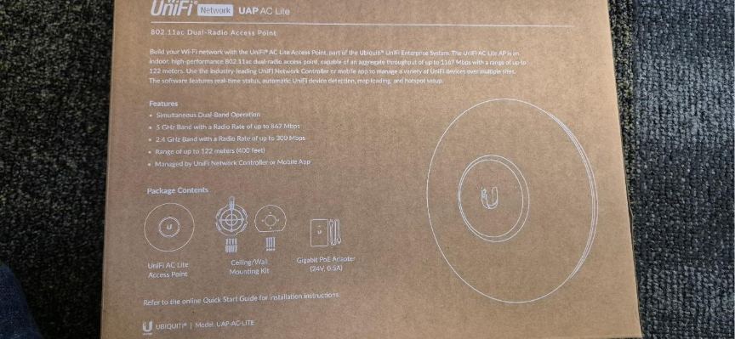

Signal Propagation in the Office
- 2.4 GHz Band:
The 2.4 GHz signal propagates further and penetrates walls more effectively. In the heatmap, the green and yellow zones indicate that classrooms, the office, and the lunchroom remain within good-to-strong signal coverage, ensuring stable connectivity for student laptops and staff desktops. Some weak areas appear near the storage and bathroom due to wall density.
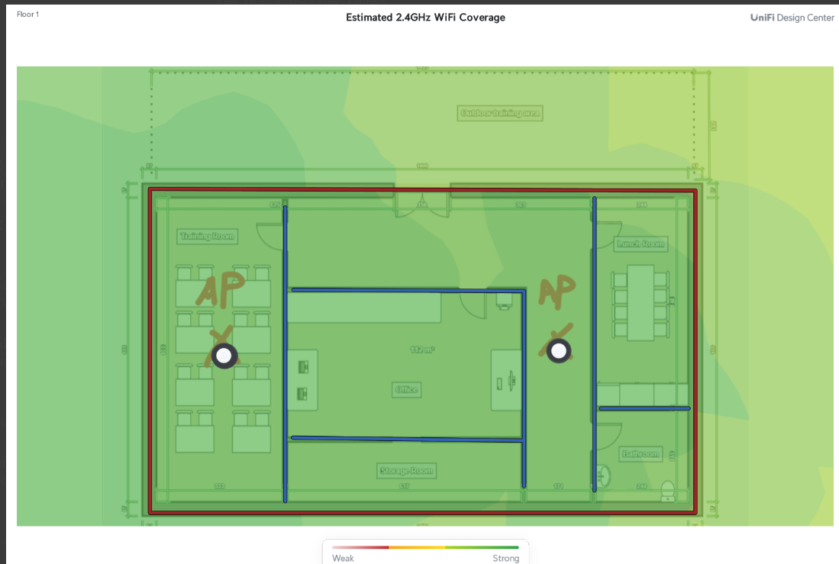
- 5 GHz Band:
The 5 GHz band provides higher throughput but has reduced wall penetration. The heatmap shows strong green coverage in the Training Room and Office, where APs are mounted, and a gradual fade into yellow and red at the perimeters. This ensures low-latency, high-speed connections for admin tasks, VoIP calls, and streaming within the central work areas.
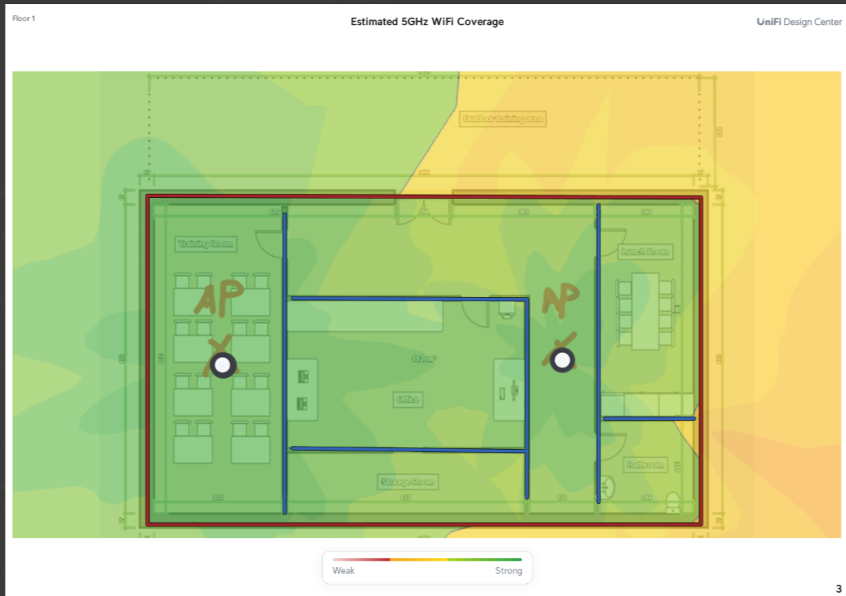
Technical Considerations
- AP Placement: One AP is centrally mounted in the Training Room to provide uninterrupted coverage for student devices. The second AP is placed in the Office/Lunch area, optimizing coverage for staff/admin use and overlapping into shared spaces.
- VLAN & SSID Mapping: Each SSID (Students, Staff, Guests, Admin) is mapped to a dedicated VLAN, ensuring segregation of traffic and reducing interference.
- Performance Zones:
  - Green Zones (Strong ≤ -60 dBm): High-quality coverage, capable of video conferencing, Microsoft Teams, and cloud access.
  - Yellow Zones (Moderate -60 to -70 dBm): Stable browsing, LMS access, and email usage.
  - Red Zones (Weak -70 to -80 dBm): Basic connectivity only; may require roaming or an additional AP if outdoor coverage is critical.

